Model Development Phase Template

Date | 12 February 2026
Team ID | LTVIP2026TMIDS34379
Project Title | AutoSage App Using Gemini Flash
Maximum Marks | 10 Marks

Initial Model Training Code, Model Validation and Evaluation Report
In this project, no custom model training is performed. Instead, a pre-trained generative AI model is integrated and used for recipe blog generation. The focus of this phase is on model selection, configuration, prompt design, and output evaluation, rather than training from scratch.

Initial Model Training Code (5 marks):
Model Selection and Initialization
The Gemini Flash (models/gemini-2.5-flash) model is selected for the AutoSage project due to its ability to process both image and text inputs, fast response time, and suitability for real-time applications.
The model is accessed using the Google GenAI SDK, and it is initialized securely using an API key stored in environment variables. The application sends a vehicle image along with a structured prompt to the model, which generates vehicle-related insights.
Since the model is already pre-trained, no training loop, loss function, or optimizer is required.
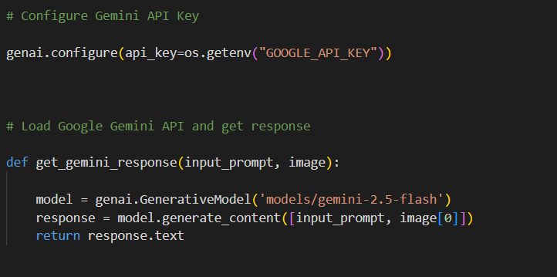

Model Validation and Evaluation Report (5 marks):
Model | Summary | Training and Validation Performance Metrics
Gemini 2.5-flash | Pre-trained generative language model optimized for fast text generation | Pre-trained multimodal generative AI model capable of understanding images and generating structured text responses

